Completing the Accounting Cycle

Table of Contents

Worksheets 3

Closing Accounts 4

The **accounting cycle** consists of the following steps:

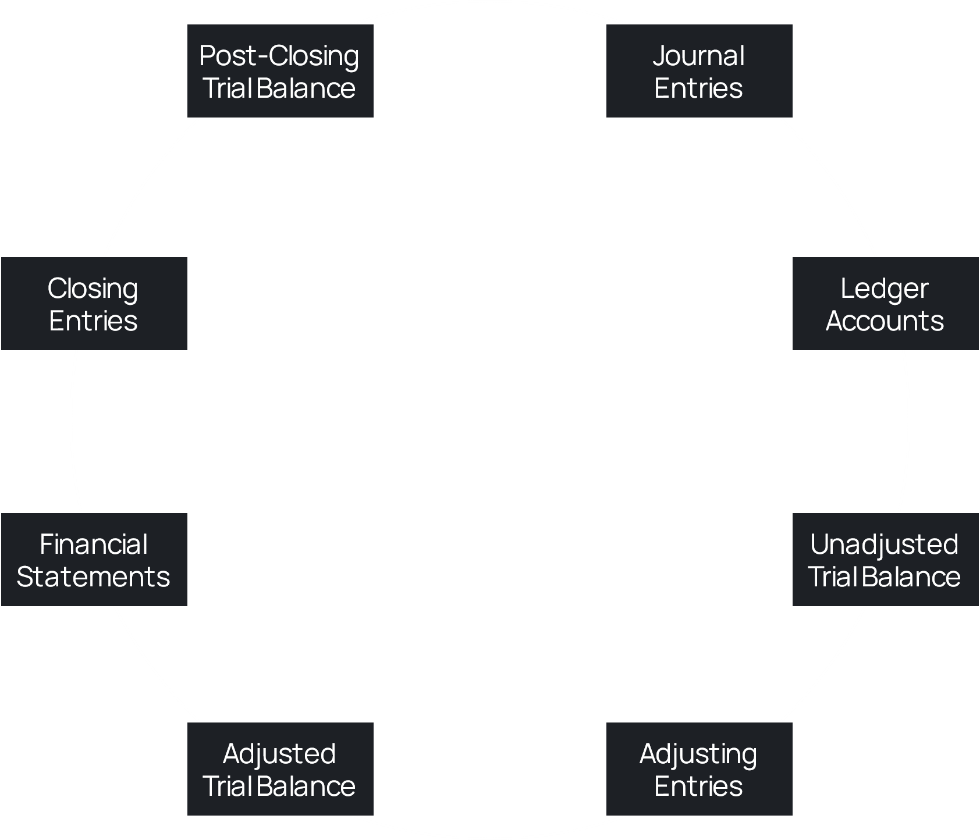

Of these, we have seen all the steps except the last two, **closing entries** and **post-closing trial balance**.

## Worksheets

A **Worksheet** is a temporary document that is used to help with the formal records that we have seen so far. It looks like this:



For a given example, we will firstly be given the **unadjusted trial balance**, which we write in the first set of columns. Next, we write the corresponding **adjustments** and finally we create the **adjusted trial balance**.

From the adjusted trial balance, we take the revenues and expenses and copy them onto the **income statement** columns and we take the assets, liabilities and owner’s equities and copy them onto the **balance sheet** columns.

## Closing Accounts

At the end of each accounting period, every company prepares the accounts for the next period. This is called **closing the accounts**. When doing this, companies divide the accounts into two categories, temporary and permanent.

**Temporary accounts** are ones that only apply to this accounting period. They include all the revenue and expense accounts as well as the owner’s drawings account. Temporary accounts are **closed** at the end of the accounting period.

**Permanent accounts** are ones that apply to one or more future accounting periods. They include all the assets and liabilities accounts as well as the owner’s capital account. Permanent accounts are **carried over** to the next accounting period.

To close the temporary accounts, we make **closing entries** in a **journal**.

|  |  |  |  |  |  |  |
| --- | --- | --- | --- | --- | --- | --- |
| General Journal | | | | | | |
| Closing Entries | | | | | | |
| Date | Accounts Title | | | Ref. | Debit ($) | Credit ($) |
| 2010 |  |  |  |  |  |  |
| Oct 31 | Service Revenue | | Dr. |  | 10,600 |  |
|  |  | Income Summary | Cr. |  |  | 10,600 |
| Oct 31 | Income Summary | | Dr. |  | 7,740 |  |
|  |  | Advertising Supplies Expense | Cr. |  |  | 1,500 |
|  |  | Depreciation Expense | Cr. |  |  | 40 |
|  |  | Insurance Expense | Cr. |  |  | 50 |
|  |  | Salaries Expense | Cr. |  |  | 5,200 |
|  |  | Rent Expense | Cr. |  |  | 900 |
|  |  | Interest Expense | Cr. |  |  | 50 |
| Oct 31 | Income Summary | | Dr. |  | 2,860 |  |
|  |  | C.R. Byrd, Capital | Cr. |  |  | 2,860 |
| Oct 31 | C.R. Byrd, Capital | | Dr. |  | 500 |  |
|  |  | C.R. Byrd, Drawing | Cr. |  |  | 500 |

There are four things happening here:

1. All the **revenue** accounts, which are credited when we gain revenue, are debited to remove their balance. The same amount is credited to **Income Summary**, which is a temporary account.
2. All the **expense** accounts, which are debited when we incur an expense, are credited to remove their balance. The same amount is debited to **Income Summary**.
3. The value of the Income Summary account is the total debit amount subtracted from the total credit amount. In the above example, this is . Since this is a **positive amount**, we have a **net income**. In this case, we debit the entire amount of the Income Summary account and credit the owner’s capital account. If we had a **net loss**, we would do the opposite.
4. Lastly, the owner’s capital account is debited by the full amount of the owner’s drawings, while the owner’s drawings account is credited.

However, we may not always have all four of these events occurring. Depending on the situation, we may have no revenues or expense are provided, so we only need to close the drawings account and vice versa.